Rigaku Miniflex II Powder X-ray Diffractometer
Preparing a Sample
Take a piece of tape and tightly wrap it around a microscope slide so that the sticky side is facing out. Place an aluminum holder on top of the slide with the tape in the hole. Rest on another slide so the assembly does not stick to the benchtop.

Your sample should be a powder so grind the sample using a rotary motion with a mortar and pestle. The finer the powder the better the data. Pour the powder on to the holder. Use another microscope slide to wipe off the excess. The diffraction angles will be more reproducible if the sample is level and as deep as the holder.

Sample Loading
When you turn the latch to open the instrument door, a shutter will block the x-rays and the yellow light labeled “shutter open” will turn off. Make sure the plastic tray is under the sample; this container ismeant to catch any powder that could fall when the sample is rotated. Insert the aluminum frame and glass slide into the clip holder.
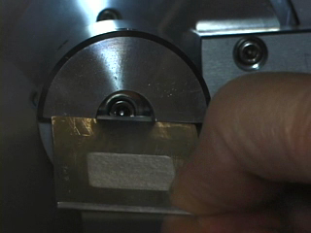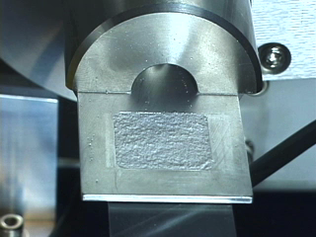

Run the Standard Measurement program and set the scan parameters.
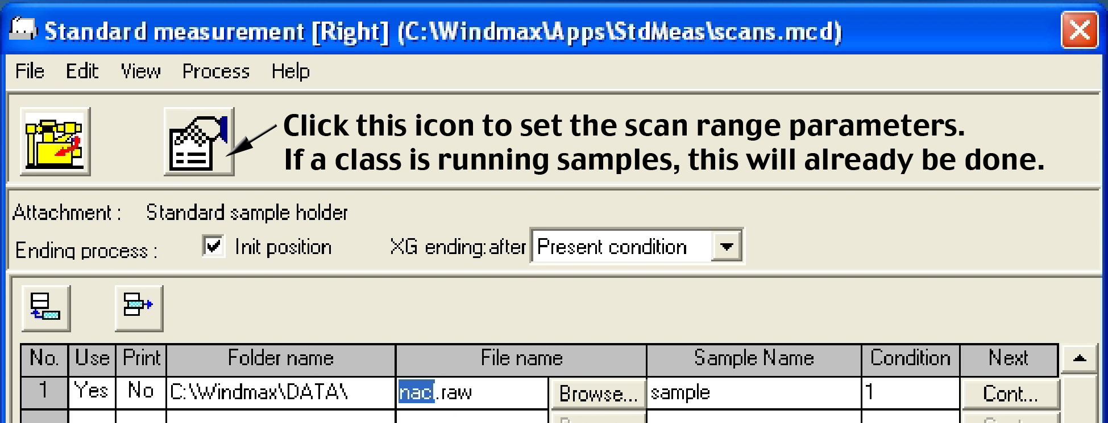
At the end of the scan return to the initial position and do not automatically print (Print = No). Only one row should be active (Use = Yes). In that row change the File name for data storage to something that includes your name.
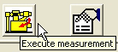 | Click on the Execute measurement icon to start the scan. As the scan occurs the counts will be displayed as a function of the scan angle. The scan will be over when it reaches the right side of the black display screen.
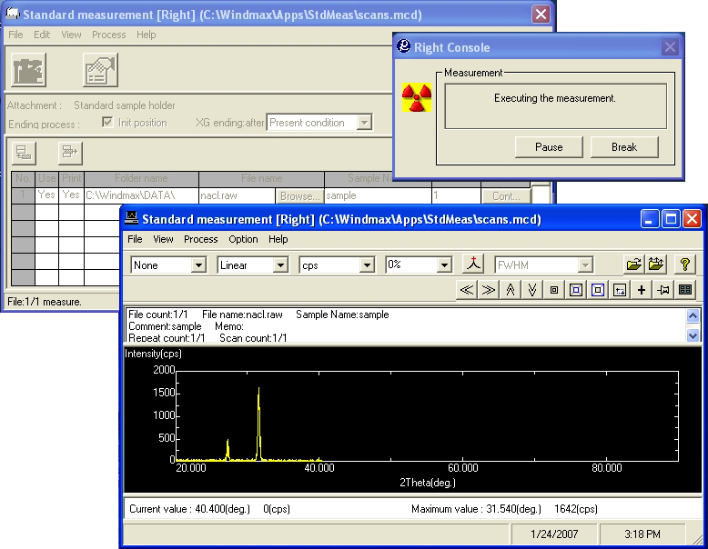

Data analysis
One program records and saves the data. A second program analyzes the data.
Open the “MDI Jade 8” program on the desktop or by tab at bottom of the window.
 | Select the file you previously created. The dog icon at the upper left allows you to fetch the most recent scan or you can use the folder icon to find files.
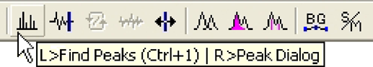 |  | Click on the icon with the vertical lines to find the peaks and display the d values. Print.

If peaks widths are needed to calculate particle size, left click on the double parabola icon to fit a parabola; right click on the same icon to list the FWHM and then print that window. Use the tallest four or five peaks for your analysis.

